## C:\Users\User\Desktop\Letters\logo\logo.png

# Smoking

**Information**

**New York State**

**Smoker’s Quitline**

Trained Quitline Specialists are waiting to offer

Nicotine Replacement Therapy

and cessation counseling

to eligible patients.

To see if you

qualify for assistance,

call the New York State

Smoker’s Quitline, toll-free at:

**1-866-NY-QUITS**

**(1-866-697-8487)**

**Or go online to:**

[**http://www.nysmokefree.com**](http://www.nysmokefree.com)

**or**

[**http://www.cliffordfp.com**](http://www.cliffordfp.com)

**(under Patients,**

**Documents & Education)**

**Why I’d want to quit**

  ____  I would save money.

  ____  I would not smell like a stale cigarette.

  ____  I would not have to look for a place

to smoke all the time.

  ____  My health would be better.

  ____  I don't like feeling addicted.

  ____  My family would stop nagging

me to quit.

  ____  Food would taste better.

  ____  I would fit in better socially.

  ____  I would feel better about my future.

  ____  I would set a good example for my

family and friends.

**Things I like about smoking**

  ____  It relaxes me.

  ____  It helps me deal with stress.

  ____  It gives me something to do.

  ____  I like how it feels to inhale.

  ____  It's always there for me.

  ____  It curbs my appetite.

**My worries about quitting**

  ____  How will I fill my free time?

  ____  How will I relax without a

morning smoke?

  ____  I'm afraid I'll gain too much weight.

  ____  What will I do when I am

driving my car?

  ____  How will I relax after dinner?

  ____  How will I cope with my emotions?

  ____  I am afraid I won't stay quit.

  ____  I won’t fit in with my family or friends.

  ____  I'll be lonely.

**Things I don't like about smoking**

   ____  The fear of getting cancer

   ____  The taste in my mouth

   ____  Frequent colds

   ____  Difficulty breathing

   ____  The expense

   ____  My dependence on it

   ____  Difficulty quitting

Clifford Family Practice

David S. Clifford, M.D.

256 Center Rd

West Seneca, NY 14224

Phone: 677-4159

http://www.cliffordfp.com

A Smoker’s guide

to smoking

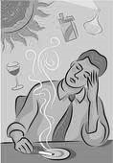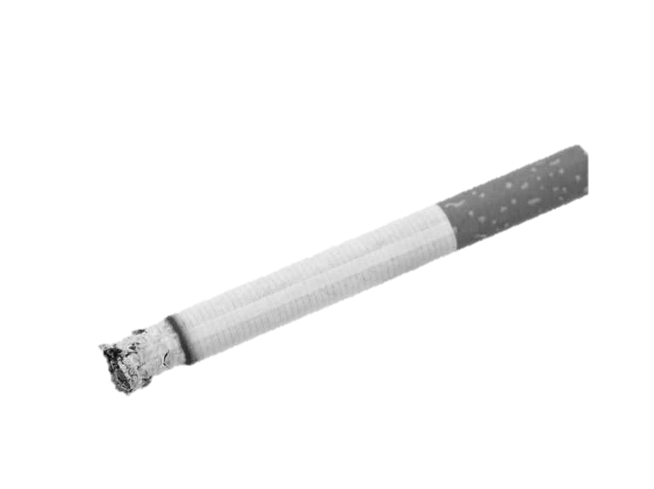

Tobacco kills more Americans each year than alcohol, cocaine, crack, heroin, homicide, suicide, car accidents, fire and AIDS ***COMBINED***.

|  |  |
| --- | --- |
| **Smokers are more**  **likely to:** | |
| Get colds and flu more often  Have shortness of breath and wheezing  Get cataracts and macular degeneration  Have gum disease and yellow teeth  Develop emphysema, chronic bronchitis, or asthma  Have problems getting pregnant Become impotent  Have problems sleeping or falling asleep  Develop premature facial wrinkles  Have memory problems Develop stomach ulcers  Have high blood pressure  Have diabetes complications  Have circulation problems |  |

|  |  |
| --- | --- |
| **Think Smoking Only Affects You?** | |
| **Children exposed to secondhand smoke**  **are more likely to get:**   * + Pneumonia   + Ear infections   + Bronchitis   + Severe asthma   + Behavior problems   + Cavities   **Adults exposed to secondhand smoke are**  **more likely to have:**   * + Heart disease   + Lung cancer   **Family pets exposed to second hand smoke**  **are more likely to develop:**   * + Breathing problems   + Sinus/nasal infections   + Nasal cancer   + Lung cancer |  |

### Common triggers that you may face:

Being around other smokers

Drinking coffee

Driving

Smelling or seeing someone smoke

Getting up in the morning

Going on break

Taking a trip

Relaxing

Finishing a meal

Using the phone

Drinking alcohol

Identify your triggers and get a plan in place for how you will deal with them.

What’s in a Cigarette?

|  |  |
| --- | --- |
| **Additives** | **Metals** |
| * Acetone -*Nail Polish Remover* * Acetic Acid - *Vinegar* * Ammonia - *Floor/Toilet Cleaner* * Arsenic - *Poison* * Butane - *Cigarette Lighter Fluid* * Cadmium - *Rechargeable Battery* * Carbon Monoxide * DDT /Dieldrin - *Insecticides* * Ethanol - *Alcohol* * Formaldehyde - *Body Tissue* * *Preservative* * Hexamine - *Barbecue Lighter* * Hydrogen Cyanide – * *Gas Chamber Poison* * Methane - *Swamp Gas* * Methanol - *Rocket Fuel* * Naphthalene - *Mothballs* * Nicotine - *Insecticide/* * *Addictive Drug* *Gasoline Additive* Phenols - *Disinfectant* * Stearic Acid - *Candle Wax* | * Aluminum * Zinc * Magnesium * Mercury * Gold * Silicon * Silver * Titanium * Lead * Copper |

**The most common diseases caused by smoking are:**

Heart disease and stroke caused by inhaling carbon monoxide

Lung cancer, caused by the carcinogens in the tar in cigarette smoke

Cancer of the lip, mouth, throat, larynx, bladder, pancreas, stomach, kidney, and cervix, caused by exposure to the toxins in cigarette smoke

Emphysema, caused by tar, and chronic bronchitis, caused by irritants in tobacco smoke



*Information from: http://www.nysmokefree.com*