Clifford Family Practice
David S. Clifford, M.D.
256 Center Rd
West Seneca, NY 14224
Phone: 677-4159
http://www.cliffordfp.com
Date | Weight | Comment
Weight
Log

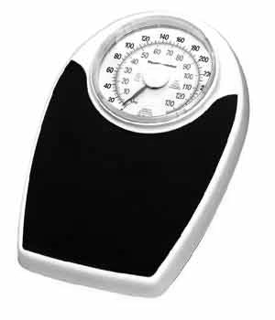

For another copy
of this log

Call

677-4159

or log on to our
website at:

www.cliffordfp.com

Under Patients,
Documents & Education

Date | Weight | Comment
Date | Weight | Comment | Date | Weight | Comment

