

**New York State**

**Smoker’s Quitline**

Trained Quitline Specialists are waiting to offer

Nicotine Replacement Therapy

and cessation counseling

to eligible patients.

To see if you

qualify for assistance,

call the New York State

Smoker’s Quitline, toll-free at:

**1-866-NY-QUITS**

**(1-866-697-8487)**

**Or go online to:**

[**http://www.nysmokefree.com**](http://www.nysmokefree.com)

**or**

[**http://www.cliffordfp.com**](http://www.cliffordfp.com)

**(under Patients,**

**Documents & Education)**

**Ready to**

**Quit**

**Smoking**

**Coping with Quitting**

**Retrain the Way You Think**

Often, patients mentally deliberate on the fact that they are thinking about a cigarette, and this leads to relapse. Patients must recognize that thinking about a cigarette doesn’t mean they need to have one.

**Review Commitment to Quit**: Each morning say, “I am proud that I made it through another day without tobacco!” Remind yourself that cravings and temptations are temporary and will pass.

**Distractive Thinking**: Use deliberate, immediate refocusing of thinking toward other thoughts when cued by thoughts of tobacco use.

**Positive Self-Talks, Pep Talks**: Say, “I can do this,” and remind yourself of previous difficult situations in which tobacco use was avoided.

**Relaxation Through Imagery**: Center your mind towards positive, relaxing thoughts

**Mental Rehearsal, Visualization**: Prepare for situations that might arise by envisioning how best to handle them. For example, envision what would happen if you were offered a cigarette by a friend.

**Continued on inside**

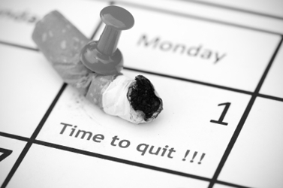



Clifford Family Practice

David S. Clifford, M.D.

256 Center Rd

West Seneca, NY 14224

Phone: 677-4159

http://www.cliffordfp.com

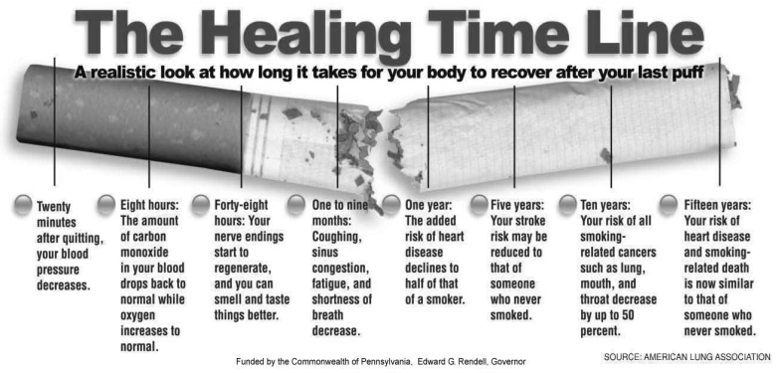

**Take Specific Actions Against Relapse**

These strategies should be considered prior to quitting, after determining patient-specific triggers and routines or situations associated with tobacco use. Below are strategies for several of the more common cues or causes for relapse.

**Stress:** Anticipate upcoming challenges at work, school, or in your personal life. Develop a substitute plan for tobacco use during times of stress (ex: deep breathing, take a break or leave the situation, use nicotine replacement therapy, among others)

**Alcohol:** Drinking alcohol can lead to relapse. Consider limiting or abstaining from alcohol during the early stages of quitting.

**Other Tobacco Users:** Quitting is more difficult if the patient is around other tobacco users. This is especially difficult if another tobacco user is in the household. During the early stages of quitting, limit prolonged contact with individuals who are using tobacco.

**Oral Gratification Needs:** Have nontobacco oral substitutes (ex: gum, candy, straws, toothpicks) readily available.

**Automatic Smoking Routines:** Anticipate routines associated with tobacco use and develop an alternative plan.

Morning Coffee: Change your morning routine, drink tea instead, take a shower before having coffee

While Driving: Remove tobacco from the car, have car interior detailed, listen to the radio, use oral substitute

While on the phone: stand while talking, limit call duration, change phone location, keep hands occupied by doodling or sketching

**Postcessation Weight Gain:** Do not attempt to modify multiple behaviors at one time. If weight gain is a barrier to quitting, engage in regular exercise and adhere to a healthy diet. Carefully plan and prepare meals, increase food and water intake to create a feeling of fullness.

**Cravings for Tobacco**: Cravings for tobacco are temporary and usually pass within 5-10 minutes. Handle cravings through distractive thinking, take a break, do something else, or take deep breaths.

Who will help you with your quitting?

My top three (3) persons who will have a positive influence on my ability to quit for good:







What form of counseling assistance will I receive while quitting?

What medications will I use for quitting, and how will I use them?

My official quit date will be

_____/_____/______

**Planning for Change:**

**Getting Ready to Quit**

Smokers don’t plan to fail. Most fail to plan.

to plan for quitting you should:

1. Identify triggers for smoking and how to cope with them
2. Identify persons to help you throughout your quit attempt
3. Choose the best methods for you for quitting.

What are YOUR three (3) main triggers for smoking?

To deal with situations when you feel the urge to smoke, you should identify the trigger situation, change what you do and how you do it, and change the thoughts that trigger the desire to smoke.

Trigger 1:

I will change what I do in this situation by:

I will change how I think in this situation by:

Trigger 2:

I will change what I do in this situation by:

I will change how I think in this situation by:

Trigger 3:

I will change what I do in this situation by:

I will change how I think in this situation by:

The Regents of the University of California, University of Southern California and Western University of Health Sciences, 1999-2009

For information on open positions or to submit your resume, please visit our Web site at: www.lucernepublishing.com